**SB-ACTIVITY REPORT (JAN to DEC-2022)**

**NOVEMBER – 2022**

1. **Orientation Programme for the Research Scholars and Special Lecture on “How to be a Successful Researcher”**

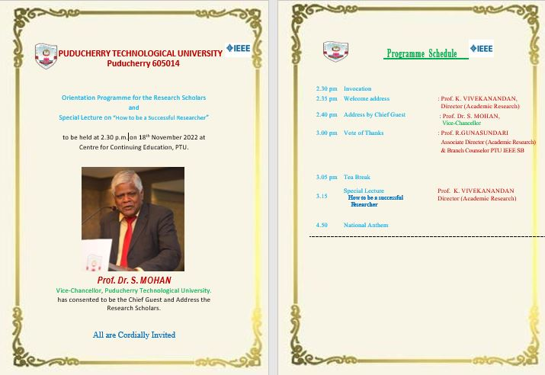One day special lecture was organized on the topic “Orientation Programme for the Research Scholars and Special Lecture on “How to be a Successful Researcher”” for the Ph.D. Scholars on Nov18th 2022.Dr.S.Mohan, Vice-chancellor, PTU and Dr. K. Vivekanandan, Director Research, PTU were the resource persons.More than 100 students attended the session and the program was organized by Dr. R. Gunasundari, Branch counselor, PTU-IEEE-SB.

**Agenda:**

Research Ethics: Scientific Integrity, Ethical and Legal Requirements, Conflict of Interest, Safety, Economy, Documentation of Data, Publication, Dissemination, Research Misconduct, Violation of ethical standards in human and animal experiments, Failure to follow established protocols, if this failure results in unreasonable risk or harm to humans or the environment and facilitating of misconduct in research by collusion in, or concealment of, such 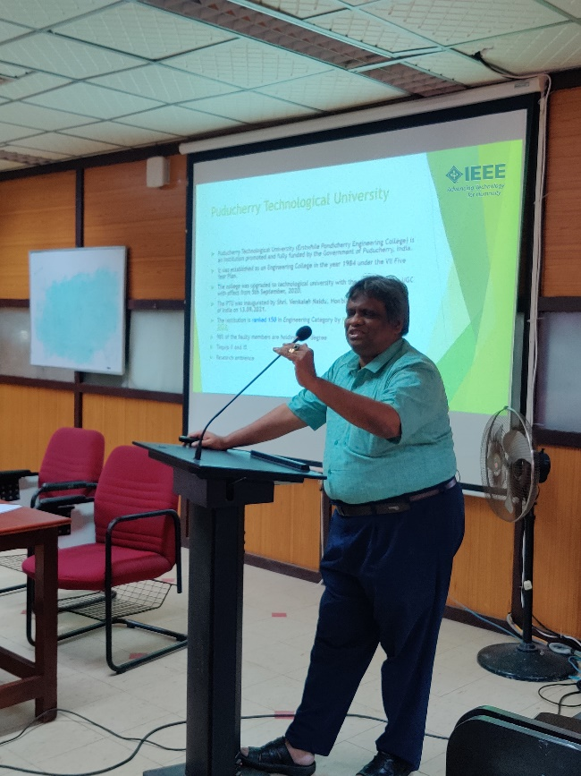actions by others

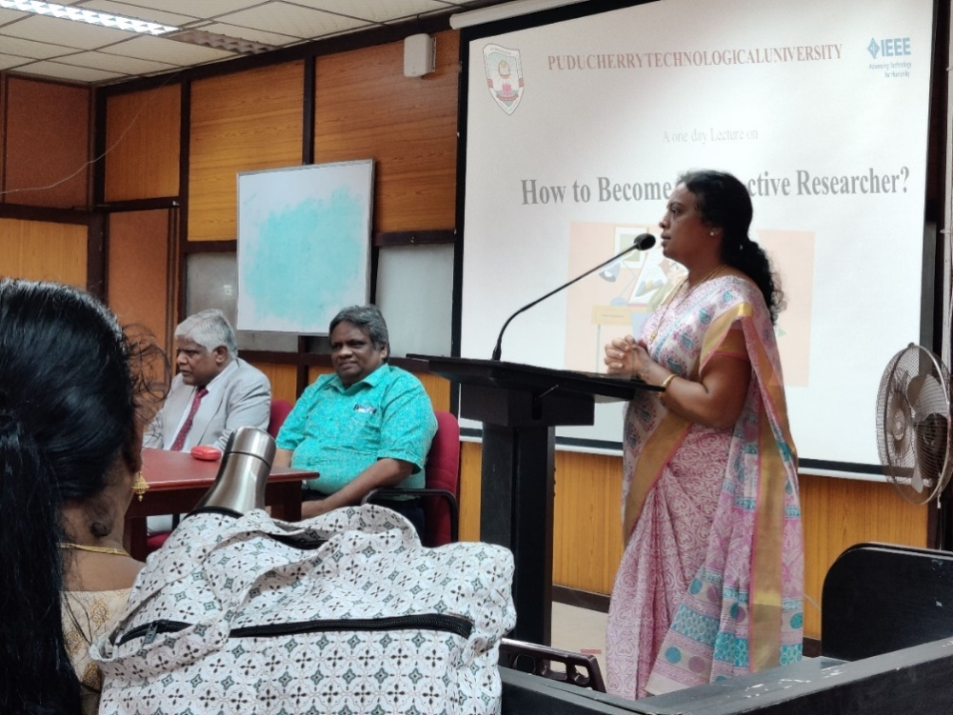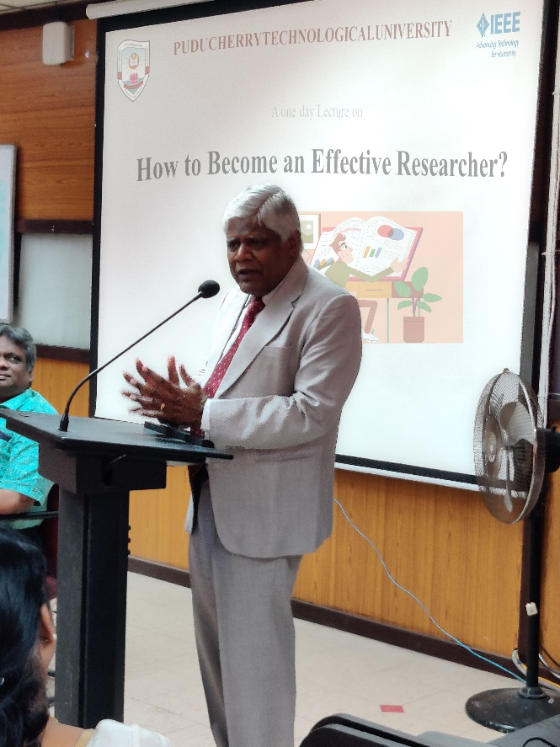

**SEPTEMBER – 2022**

1. **IEEE DAY CELEBRATIONS**

Two Special Guest Lectures were organized on account of IEEE Day, on the topics "What Industry wants from EEE and ECE Graduate Students?" by Mr. Koti Reddy, Scientific Officer, Department of Atomic Energy and "Evolution of Cellular Communication Technology from 1G to 5G" by Mr. Sushil Kumar, Scientific Officer, Department of Atomic Energy.

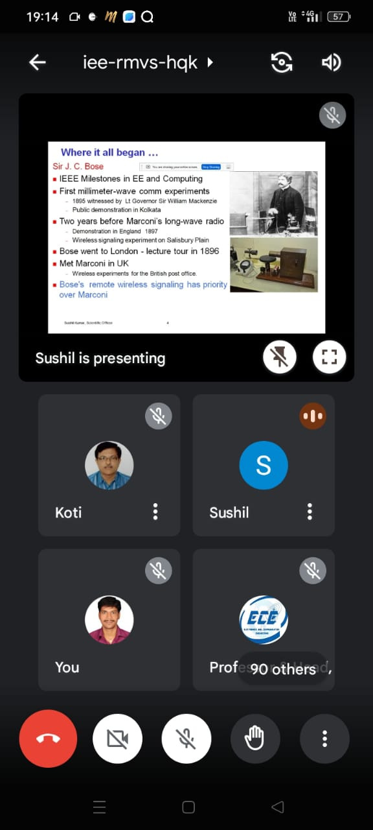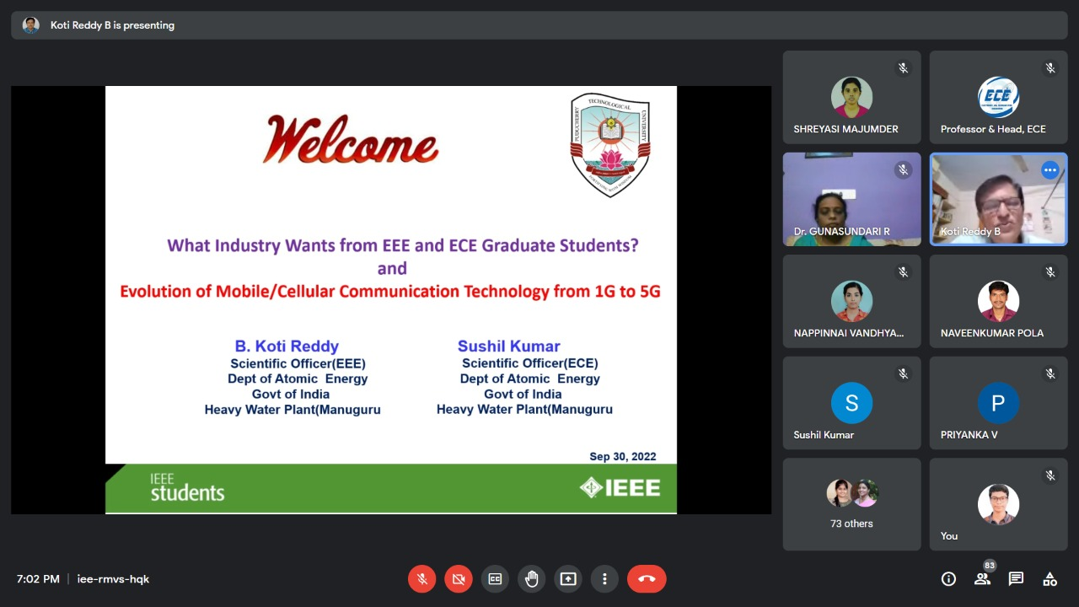

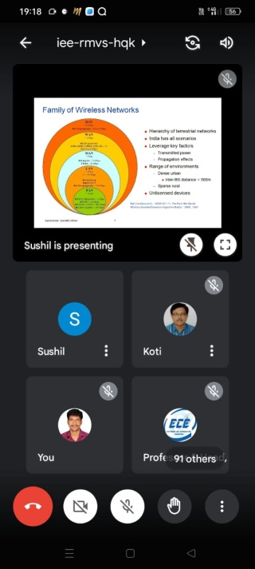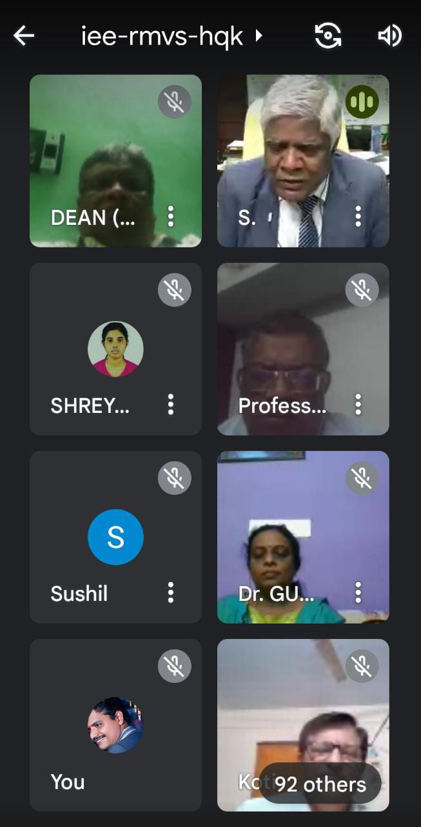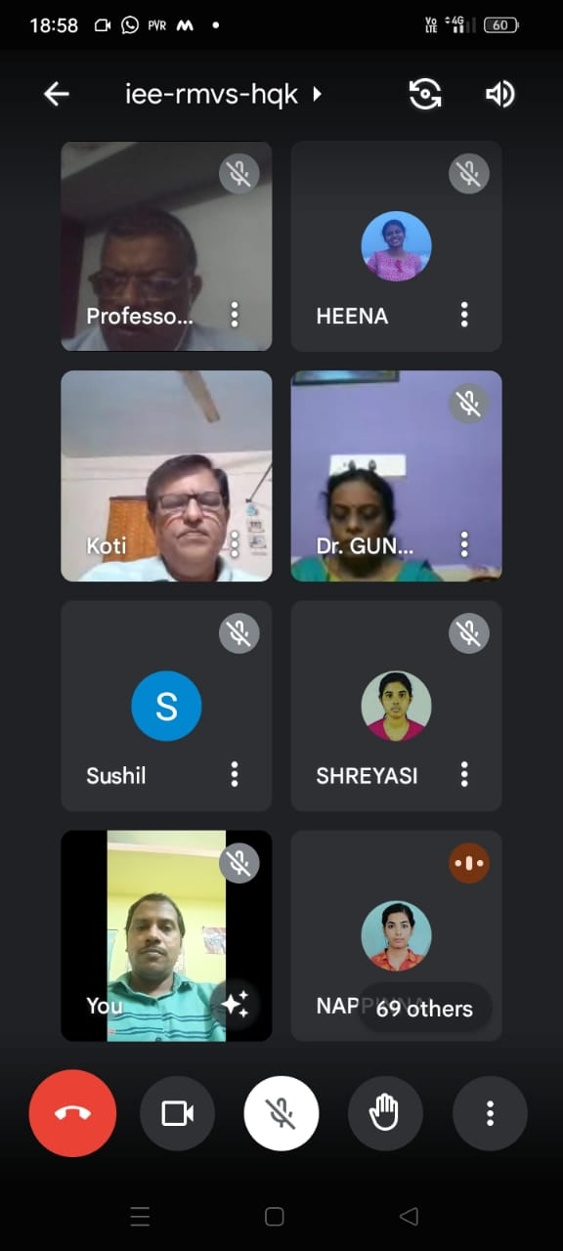

1. **LATEST TRENDS IN DATA NETWORKING**

**A series Lecture series was conducted on 05thAugust, 2022 on topic “LATEST TRENDS IN DATA NETWORKING”**

**Event Coordinators:**

|  |  |
| --- | --- |
| **Event Coordinators** | |
| Dr. R. Gunasundari | Mr. P. Naveen Kumar |
|  |  |
| (PTU IEEE SB Branch Counselor) | (PTU IEEE SB Branch Chair) |
| **Speaker** | |
| Mr Rao | |
| C:\Users\Administrator\Downloads\1597924_NarasimhaRao_Chennai.jpg | |

**Agenda**

* NETWORKING ARCHITECTURE
* 5G MOBILE BACKHAUL ARCHITECTURE
* TRADITIONAL NETWORK ROUTER ARCHITECTURE
* GENERIC ROUTER ARCHITECTURE

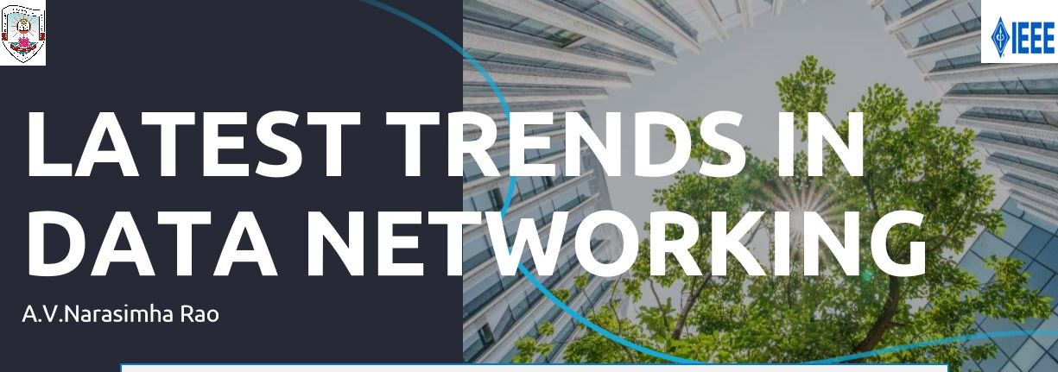

1. **NETWORKING FUNDAMENTALS**

**A series Lecture series was conducted on 29th July, 2022 on topic “NETWORKING FUNDAMENTALS”**

|  |  |
| --- | --- |
| **Event Coordinators** | |
| Dr. Thachayani Masilamani | Dr. A.V.Ananthalakshmi |
|  |  |
| (Assistant Professor ECE) | (Assistant Professor ECE) |
| **Speaker** | |
| Mr Rao | |
| C:\Users\Administrator\Downloads\1597924_NarasimhaRao_Chennai.jpg | |

**Agenda**

**1. OSI Model Overview**

**2. Layer 2 Overview**

**3. STP**

**4. VLAN**

**5. Layer 3 Overview**

**6. RIP**

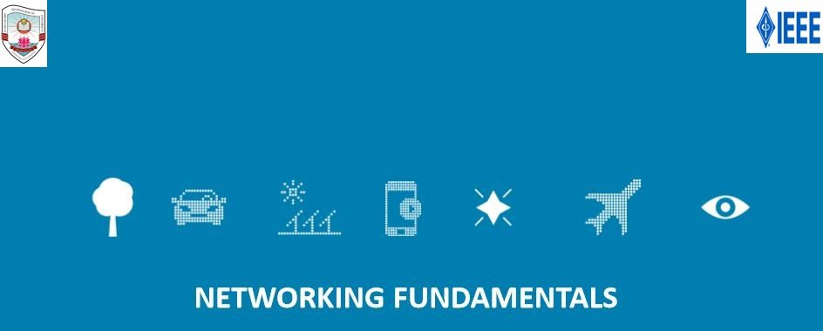

1. **INTRODUCTION TO NETWORK ROUTERS**

**A series Lecture series was conducted on 22nd July, 2022 on topic “INTRODUCTION TO NETWORK ROUTERS”**

|  |  |
| --- | --- |
| **Event Coordinators** | |
| Dr. R. Gunasundari | Mr. P. Naveen Kumar |
|  |  |
| (PTU IEEE SB Branch Counselor) | (PTU IEEE SB Branch Chair) |
| **Speaker** | |
| Mr Rao | |
| C:\Users\Administrator\Downloads\1597924_NarasimhaRao_Chennai.jpg | |

**Agenda**

* **Typical Routers**
* **Router Architecture**
* **Control Plane & Data Plane**
* **Generic Router Architecture**
* **Chassis based Routers**

**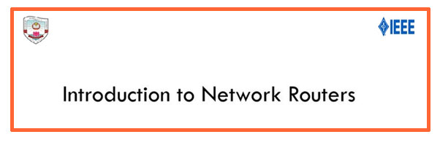**

1. **IP NETWORKS**

**A series Lecture series was conducted on 15th July, 2022 on topic “IP NETWORKS”**

|  |  |
| --- | --- |
| **Event Coordinators** | |
| Dr. R. Gunasundari | Dr. A.V.Ananthalakshmi |
|  |  |
| (PTU IEEE SB Branch Counselor) | (Assistant Professor ECE) |
| **Speaker** | |
| Mr NARASIMHA | |
| C:\Users\Administrator\Downloads\1597924_NarasimhaRao_Chennai.jpg | |

**AGENDA**

**• Internet Arch**

**• Need for IP**

**• Internetwork**

**• IP addressing, subnet concepts**

**• IP Header**

**• IP options.**

**• Address Assignment**

**• IP Routing**

**• ARP**

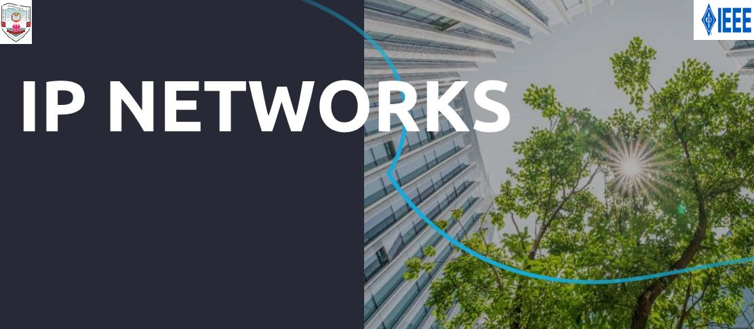**• ICMP and Traceroute**

1. **INTRODUCTION TO LINUX**

**A series Lecture series was conducted on 8th July, 2022 on topic “INTRODUCTION TO LINUX”**

|  |  |
| --- | --- |
| **Event Coordinators** | |
| Dr. R. Gunasundari | Dr. Thachayani Masilamani |
|  |  |
| (PTU IEEE SB Branch Counselor) | (Assistant Professor ECE) |
| **Speaker** | |
| Mr Rao | |
| C:\Users\Administrator\Downloads\1597924_NarasimhaRao_Chennai.jpg | |

**Agenda:**

* **History and introduction**
* **Linux Variants**
* **Linux Features**
* **Linux Architecture**
* **Linux kernel**
* **Linux Modes**
* 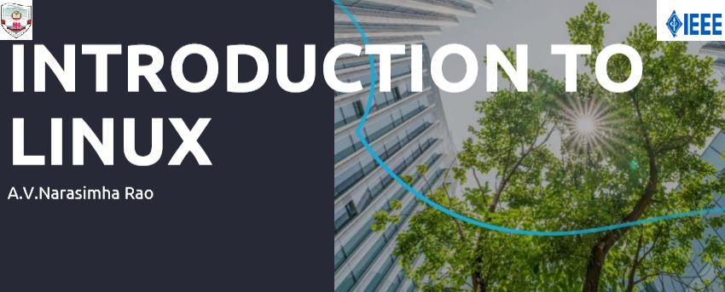**Packaging**

**MAY – 2022**

1. **Invited talk on Geoinformatics by Dr. A. Senthil Kumar, President, ISPRS Technical Commission on Education and Outreach**

An invited talk on “Geoinformatics and Societal Applications – Opportunities & Challenges” was conducted by the Department of Electronics and Communication Engineering of Puducherry Technological University on 19th May 2022. The chief guest of the event is Dr. A. Senthil Kumar, President, ISPRS Technical Commission on Education and Outreach, Director, UN-affiliated Regional Centre: CSSTEAP and Former Director, Ind. Inst. Remote Sensing (ISRO Unit). Initially he had an interaction with the faculty members of ECE and EIE departments. During which he insisted on interdisciplinary collaborative research works. He also addressed the second year B.Tech(ECE) students and mentioned the research areas that the University can take up in the field of Geoinformatics. Honourable Vice-Chancellor Prof.S. Mohan of Puducherry Technological University presided over the function. Dr.Gnanou Florence Sudha, Head of the Dept, ECE welcomed the gathering. Dr. A.V.Ananthalakshmi, Assistant Professor, ECE Deptco-ordinated the function.

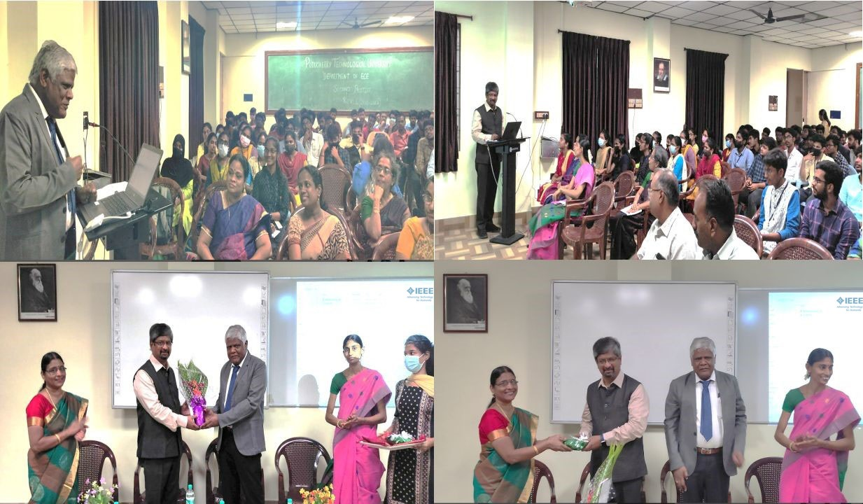

**APRIL – 2022**

1. **FORMAL INAUGURATION OF IEEE STUDENTS BRANCH (ERSTWHILE PEC)**

The Student Branch of IEEE was started in Puducherry Technological University (PTU) (erstwhile Pondicherry Engineering College) in 1995 by our beloved former principal Prithvi raj. Now due to our upgradation to PTU, the Inauguration of IEEE PTU Students Branch was done on 20th April ,2022. Since then, it has developed into a multifaceted student club on campus, organizing a wide variety of technical events for the benefit of students. The Student Branch attempts to provide a platform for students from different branches and years to connect with each other and all IEEE members worldwide. Student members have the choice to get involved in technical projects, presentations, website building and maintenance and non-technical aspects such as marketing, volunteering for IEEE events and networking with other student branches. Other IEEE student branch activities are to facilitate PTU students to participate in national and international conferences, workshops, project/design competitions, industrial visits and access to IEEE online resources.

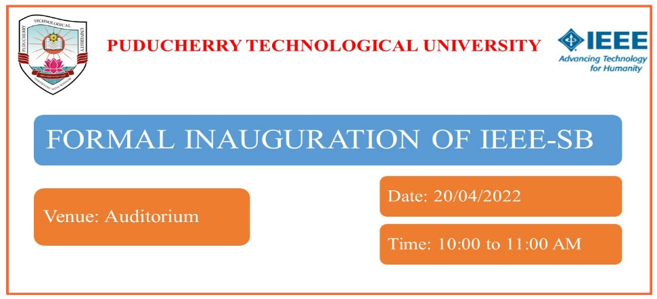

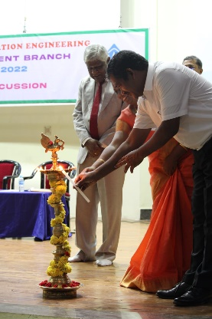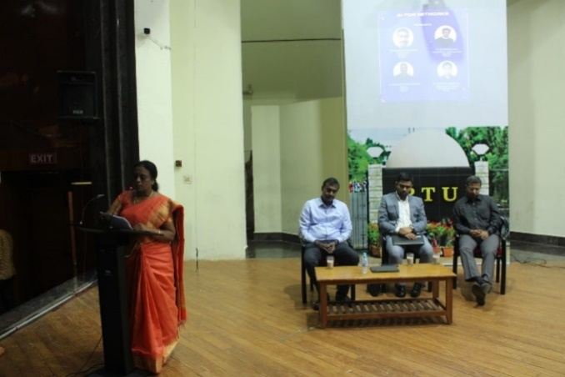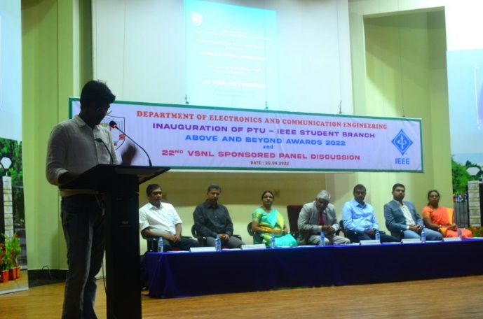 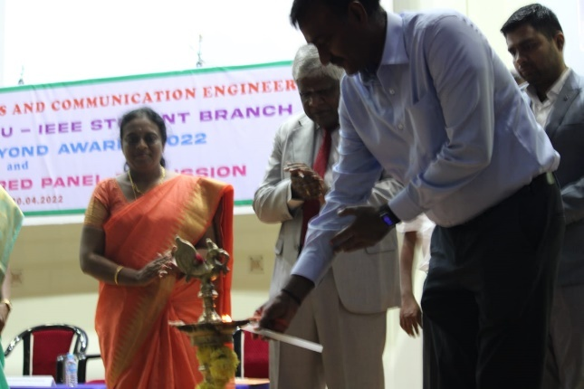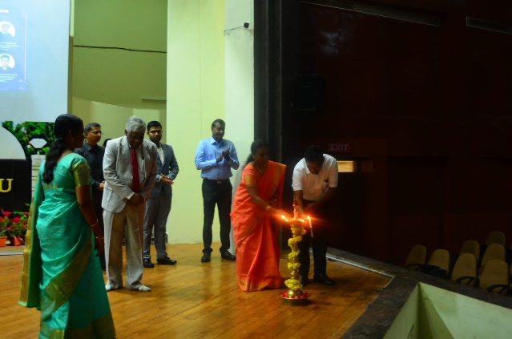

1. **PANEL DISCUSSION ON AI FOR NETWORKS**

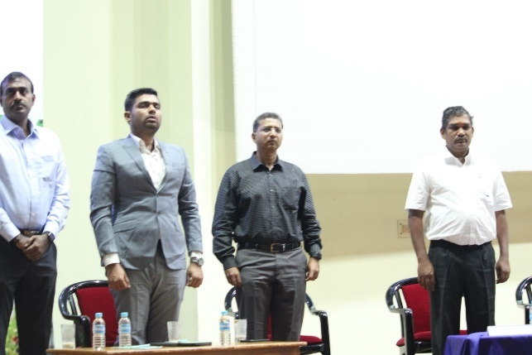The panelist are Mr. ArumugamVelayoudame (Anchor and Panelist), Director Engineering, Qualcomm, Bangalore, Anchor for the discussion, and Industry Experts, MrSurajVenkatraman, Sr. Director, Global operations,.M/s.Capgemini. Chennai, Mr.NandakumarNadarajane, Director, Capgemini, Chennai and Mr. HarishreyasNeelakantan, Sr. Lead Data Scientist, M/s. Tata Communications Ltd, Chennai.

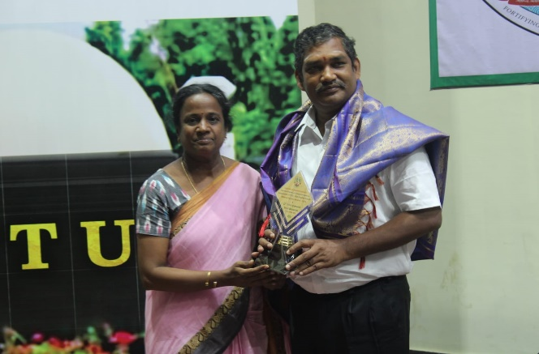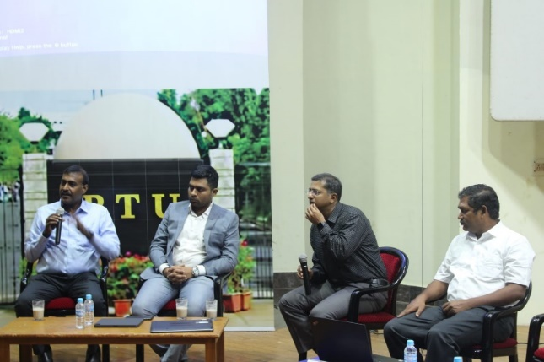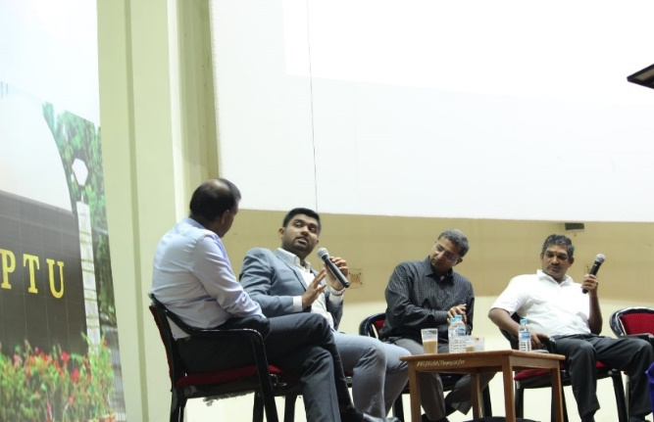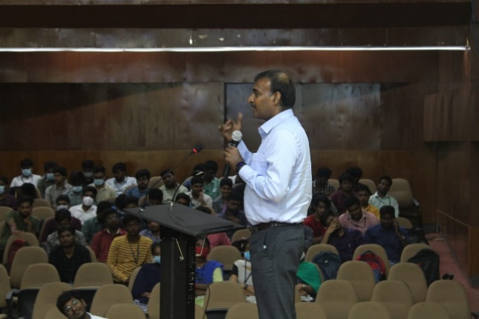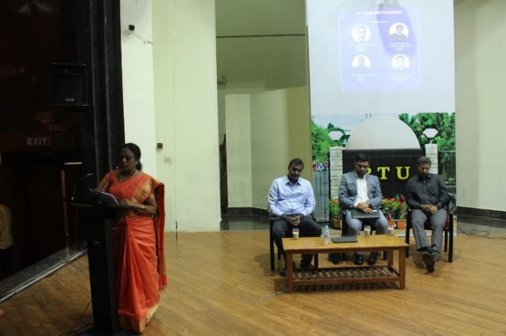

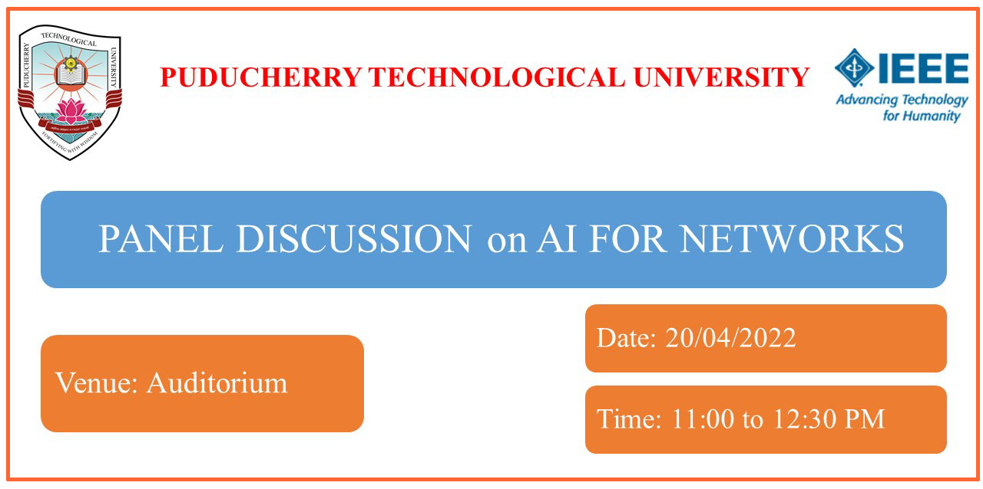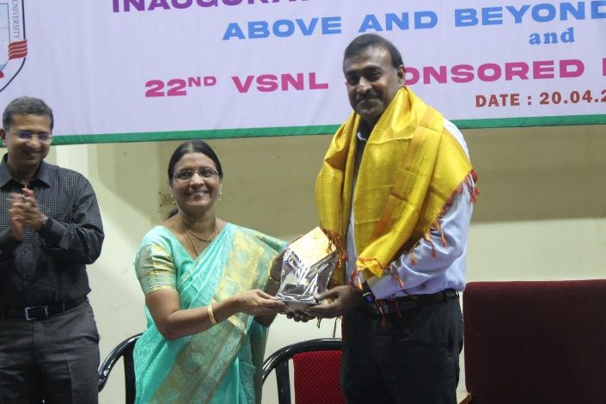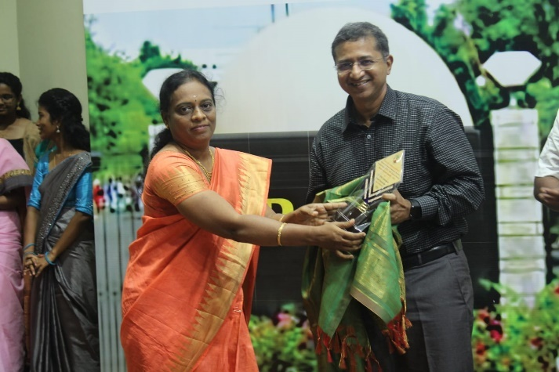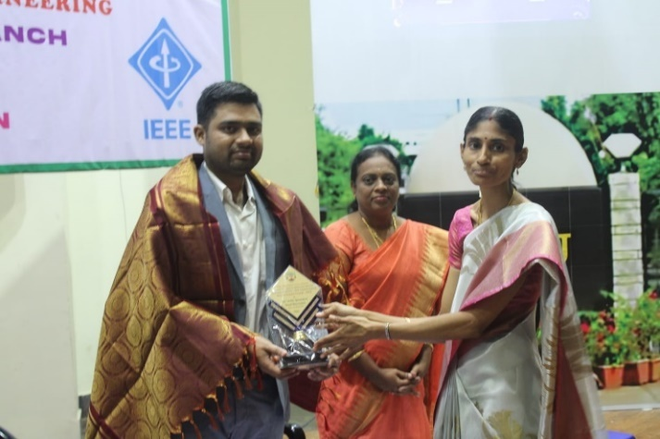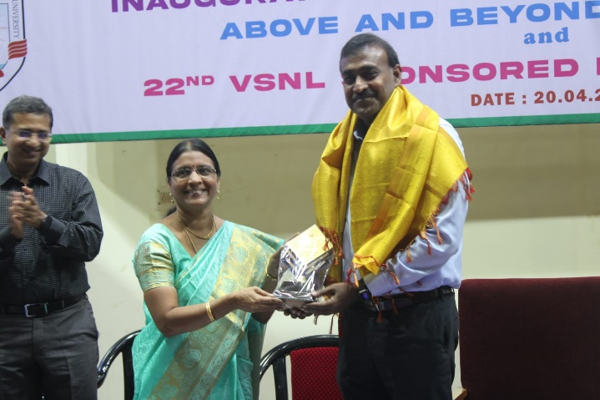

1. **PROJECT EXPO-2022**

**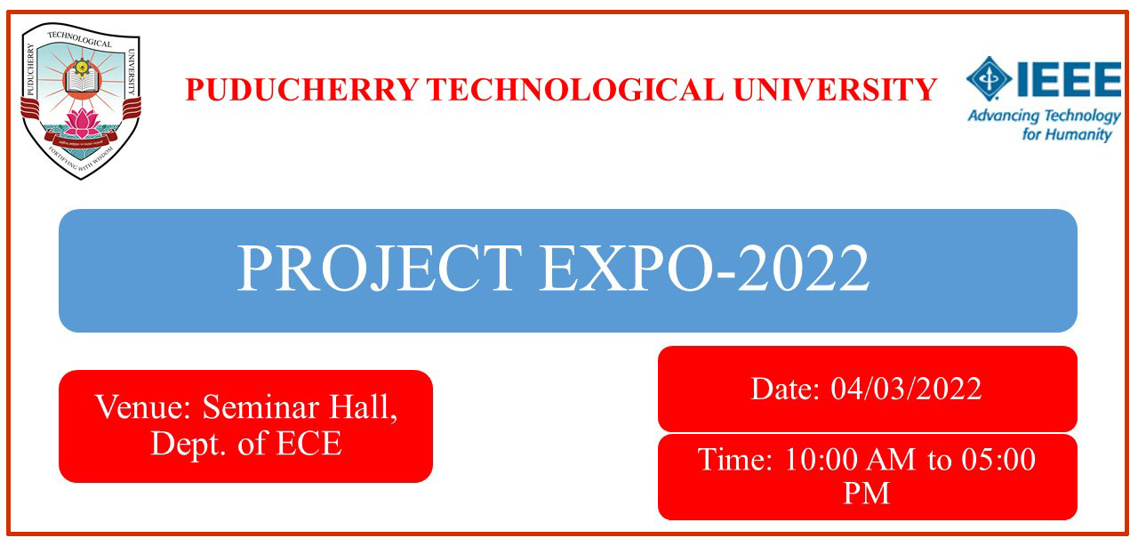**

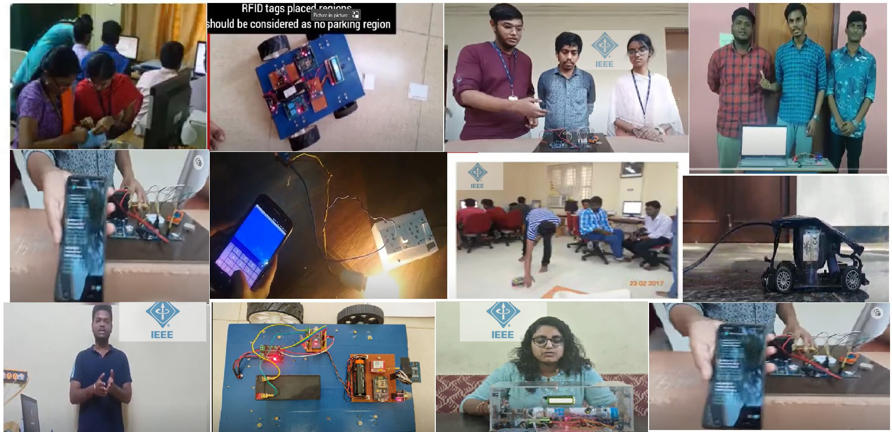

**Project Expo 2022**: The final demo cum presentation for the project expo will be held on 04.03.2022. The faculty mentors concerned are requested to inform the shortlisted teams to appear before the selection committee on 04.03.2022 at 10.00am onwards in the Seminar hall, ECE Department. Each team will be given a maximum of fifteen minutes for presentation and demonstration of their project.

1. Design of a 32-bit processor based on RISC – V Architecture     -  <https://youtu.be/xzqjcZlF444>
2. 2. Smart Pothole detection for Two-Wheelers during floods-   <https://www.youtube.com/watch?v=FWK-UCE2Pvo>
3. Patient monitoring system using IoT -  <https://www.youtube.com/watch?v=bhOEi9scY4s>
4. Handling Traffic Regulation using RFID and IoT -  <https://www.youtube.com/watch?v=YK4YO6gt0Lg>
5. Smart Pothole detection for Two-Wheelers during floods - <https://youtu.be/BVGmOyhv9DY>
6. Assistive system for improving livelihood of visually impaired by using Li-Fi -  <https://youtu.be/Fglw-rEyS7k>
7. Smart Security Surveillance System using IoT**-**<https://youtu.be/BVGmOyhv9DY>

**Event Coordinators:**

Dr. Gnanou Florence Sudha Dr.A.V.Anathalakshmi

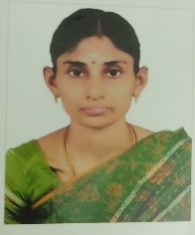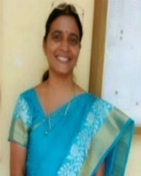

**Jury members:**

Dr. M. Arunachalam, Assoc. prof, EEE, PTU. Dr. K. Sarulatha, Assoc. prof, CSE, PTU.

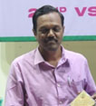

The following teams compete for the Project expo 2022. The final demo cum presentation for the project expo will be held on 04.03.2022. The faculty mentors concerned are requested to inform the shortlisted teams to appear before the selection committee on 04.03.2022 at 1.30pm in the ECE Department. Each team will be given a maximum of fifteen minutes for presentation and demonstration of their project.

**Final Teams**

|  |  |  |  |  |
| --- | --- | --- | --- | --- |
| **SI.No** | **Title of the Project** | **Students** | **Batch** | **Faculty Mentors** |
| 1. | Patient monitoring system using IoT | 1. G. Dheepak | 2018-2022 | Dr. R. Sandanalakshmi |
| 2. | Smart Security Surveillance System using IoT | 1. A.S. AshikaBegam 2. S. Dharanidharan 3. P. Gowthamaan | 2018-2022 | Dr. A.V. Ananthalakshmi |
| 3. | Smart Covid Surveillance | 1. Ashish Kamalesh Singh 2. Manith Ruby Vazirani 3. Mahipal Singh K. Rajpurohit | 2019-2023 | Dr. K. Jayanthi |
| 4. | Design of a 32-bit processor based on RISC – V Architecture | 1. K. Navinkumar | 2019-2023 | Dr. M. Thachayani |
| 5. | Forest fire Preventive Informer (IoT Based) | 1. Medwin Mirza | 2019-2023 | Dr. S. Batmavady |
| 6 | Handling Traffic Regulation using RFID and IoT | 1. K. ThanushAravinde 2. R. Sriramachandran 3. K. Sivabharath | 2020-2024 | Dr. Gnanou Florence Sudha |
| 7. | Smart Pothole detection for Two-Wheelers during floods | 1. T. C. Adityaa 2. Ra. Srinethe 3. N. Pranav | 2020-2024 | Dr. L. Nithyanandan |
| 8 | Assistive system for improving livelihood of visually impaired by using  Li-Fi | 1. Shiva Sai | 2020-2024 | Dr. S. Tamilselvan |

1. **Alumni interaction event with ECE Alumnus - Mr. Chandra Sekhar (2000-2004) batch, Director (Engineering), CISCO, US held on 11.4.2022.**

An invited talk by our ECE Alumnus of the 2000-2004 batch, Mr. Chandra Sekhar, Director - Engineering, CISCO, US is arranged for the 3rd year B.Tech (ECE) students in the Smart Class room of our Department on 11th April 2022 at 11 am.  Our Honorable Vice Chancellor Prof. Dr. S. Mohan Vice Chancellor, PTU delivered the Presidential address.

